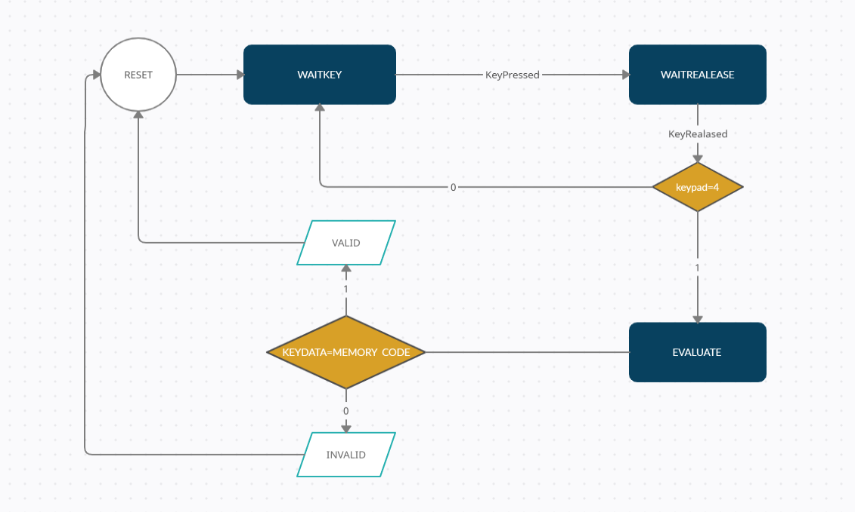

STATE DIAGRAM

It did not mention Reset in the question, but I added it. Because the system needs to be reset.

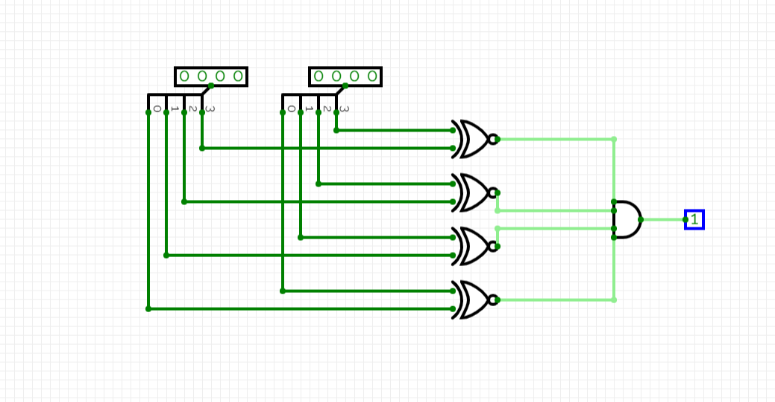

The sub-circuit which I use in my circuit. It makes a comparison and outputs 1 if it is equal.

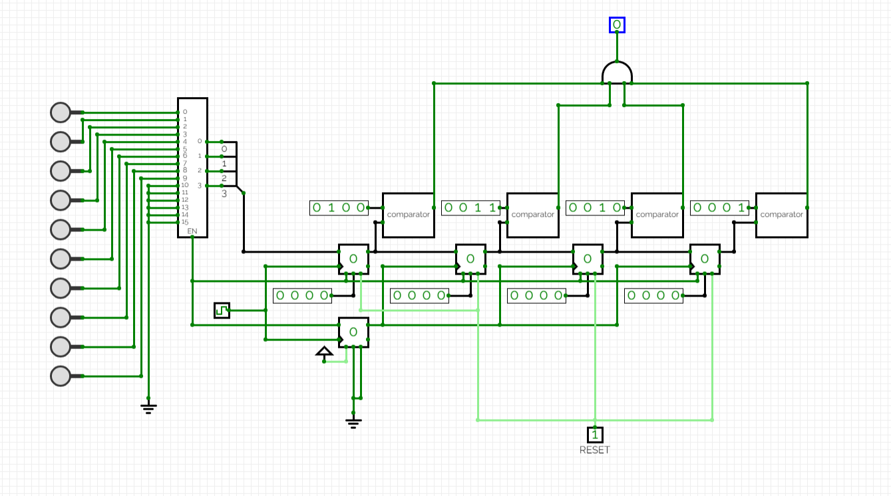

idle status of the circuit

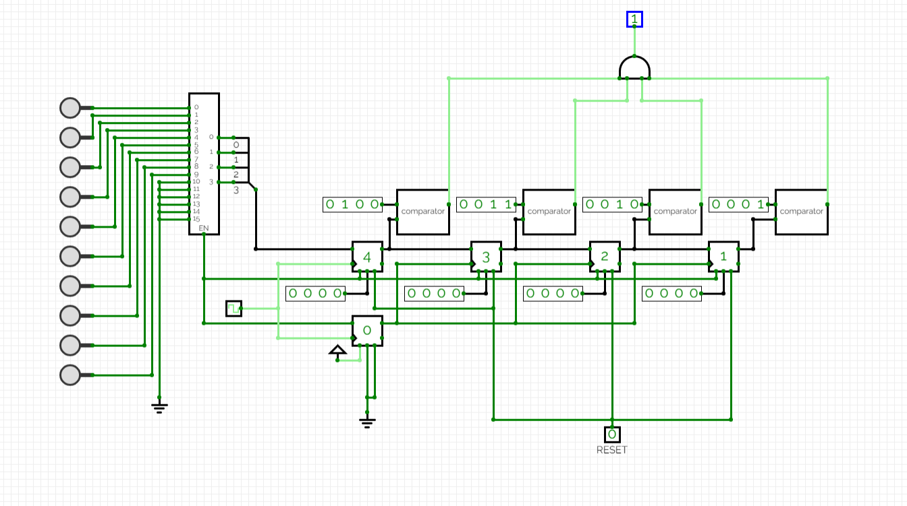

when we enter "1,2,3,4" respectively

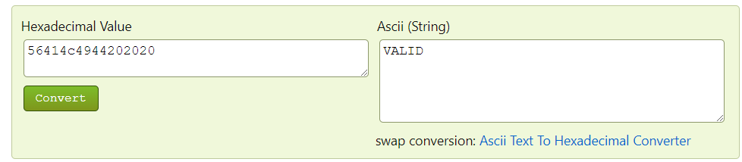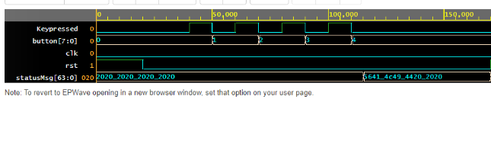**Valid Run**

I tried in 2 cases within the same test code. As you can see, here comes "1,2,3,4" as the input from the button. When we put the hex code I received as output into the converter, we get the “VALID” result.

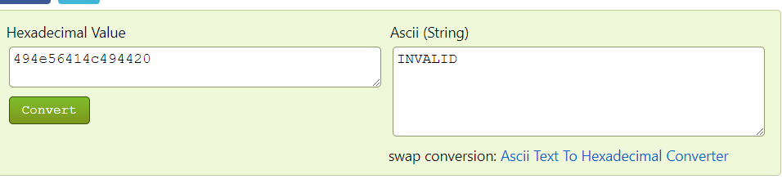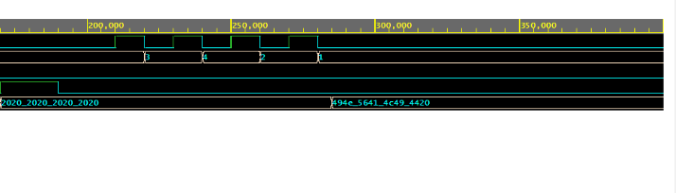**Invalid Run**

After reset, I send "3,4,2,1" as the input to the button. This is my invalid case. When we put the hex code I received as output into the converter, we get the “INVALID” result.

